1. **Stored Procedure** — Show enrollments of a student by ID

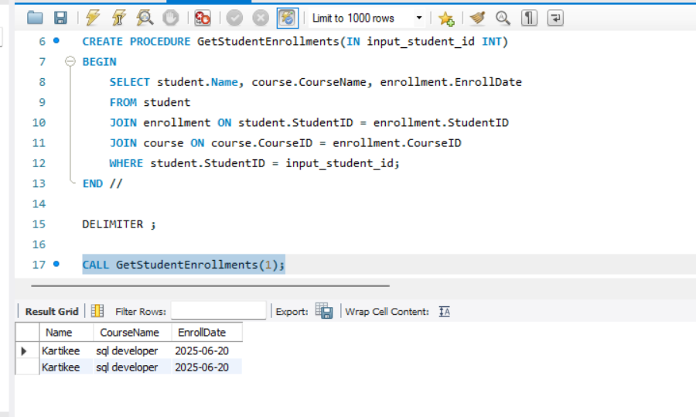

1. **Function — Count how many courses a student is enrolled in**

